Cultural Awareness

Document

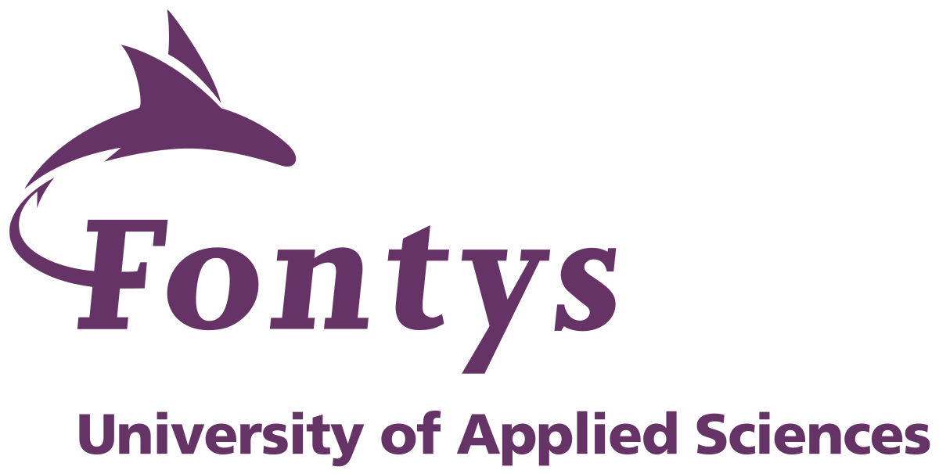

Author: Stanislav Petkov (4222024)

Class: S3-CB04

Date: 26/11/2021

Contents

Introduction 3

My Personal Experiences 4

How to adapt when working in a multicultural team 5

Conclusion 5

# Introduction

Nowadays due to globalization the world is a lot more open for most people, if you have the willpower, you can go wherever you desire, therefore it is a lot more common for people to study/work abroad. What a lot of people don’t realize at first though is that when you travel to a whole new country you might encounter people with entirely different behavior and mentality than yours, which is mainly due to your cultural differences.

As many others, I have decided to study abroad as well. Here in the Netherlands, there is huge cultural diversity, you can basically meet people from all over the world when living here, which allows you to explore brand new perspectives on life and perhaps develop your creativity, but it can also pose some challenges.

In the next few paragraphs, I am going to describe my experience interacting with people from different cultures so far and suggest possible solutions/improvements when dealing with such people.

# My Personal Experiences

The first time when I really notice a major difference in behavior and beliefs was when I was assigned to work on a project with a girl from Oman (located in the Arabian Peninsula). When talking to her I noticed that she was a lot more reserved and quite compared to most Europeans, she always completed the tasks she was given but never took the initiative with planning and dividing the workload. We completed the project and I moved on, didn’t think much of it at the time, I just thought she was just a shy person, but later on I noticed that this was a trend with a lot of people coming from eastern countries and then learnt that this is due to the fact that people in Asia perceive silence very differently compared to the western world. Most of the time, to us silence indicates disagreement or a lack of attention, however in the eastern world remaining silent is very common and, in most cases, means agreement, respect, thoughtfulness etc.

The next major difference I encountered while living in the Netherlands was the Dutch mentality, when working with Dutch people I noticed that most of the time they are focused only on completing their own tasks and reluctant to ask for or give somebody help. In my opinion for the majority of Dutch people success comes first and their personal relationships are lower on their priority list. This surprised me, because in my home-country Bulgaria people are much more open to help and communicate their own problems as well.

In my opinion, the main reason for this happening is the individualistic mentality of the Dutch people, because as I can see in a collectivistic society like the one in Bulgaria people deal with their goals and problems with the support of others most of the time, which is vastly different compared to the Netherlands. Being goals driven has its ups and downs of course, but I believe that the most productive mindset would be a combination of both individualism and collectivism.

# How to adapt when working in a multicultural team

When working in a cultural-diverse team, it is very important to be aware of the cultural differences between you and the rest of the team, to prevent any conflicts withing the team various strategies should be adapted. For instance, this semester I am participating in a group project with people of 4 different nationalities. To avoid any misunderstanding, clear communication has been a top priority for us. Every week there are 3 mandatory team meetings, where we discuss our goals, progress, and problems. Everybody is encouraged to speak up in case of any potential issues, so that major problems can be avoided. Apart from that we also have a weekly discussion with our mentor about our current situation, where useful tips and support for the group are provided. Overall, I believe that sticking to a consistent meeting schedule has had a very positive effect with regards to communication and our progress in general.

# Conclusion

Since living in the Netherlands, I have encountered a lot of different cultures, and this has opened my eyes on some potentials issues that may arise when working with people from different backgrounds. In the future, first I am going to try and get to know the people I am working with, then establish a clear way of communication and let my intentions/values be known. Once I am aware of all my coworkers’ beliefs and a solid communication strategy is put in place, then I can start working/collaborating on the tasks ahead.

Overall, I think that people should be more open-minded to new ideas/beliefs because it can improve their thinking as well. Finally, I would say that is very important to make sure that you never disrespect another person’s values, even if you don’t believe in them.